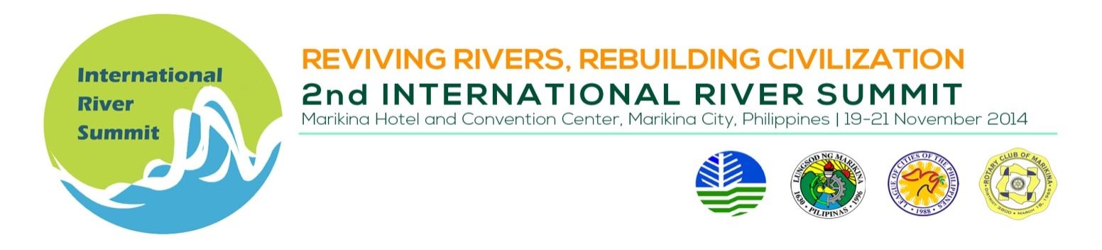
INDICATIVE PROGAMME

Thematic Session 10 : Translating CCA-DRR into policy and action

Venue : El Valle, 3rd flr, Marikina Hotel

Date/Time : November 20, 2014, 1:30 – 5:00 PM

Session Chair : Mr. Vic Aquitania, Executive Director, ICLEI-Southeast Asia

TIME | TOPIC | SPEAKER
 | SESSION INTRODUCTION | Mr. Vic Aquitania
 | Mainstreaming CCA-DRR | Dr. Candido A. Cabrido, Jr., National Climate Change Adaptation and Disaster Risk Management Specialist/ President, Society for the Conservation of Philippine Wetlands
 | Integrating CCA and DRR in development planning | Ms. Shirley Torrecampo- Bolanos, Executive Director, Coastal CORE, Inc., Philippines
 | BREAK
 | Mainstreaming CCA-DRR in river management: key principles and challenges | Mr. Justin See, Systems and Dynamics Consultant, Coastal Cities at Risk, Manila Observatory, Philippines
 | Mindmapping Exercise: Identifying Entry Points and Challenges in Integrating CCA-DRR into River Basin Management in Southeast Asia  Facilitators: ICLEI-Southeast Asia | ICLEI-Southeast Asia

